Adaptive Routing by Fusion Message Ferrying

Related works:
There have been some works on Message Ferrying scheme to deliver messages between partitioned ad hoc networks.

- SIRA—Ferries move along a single ferry route. And regular nodes are stationary. The ferry route traverses through all the stationary nodes, and data exchange occurs when a ferry meets a node. As regular nodes are stationary, an optimized ferry route could be determined to reduce delay and message dropping. In addition, there are no interactions between ferries.
- MURA—Ferries move along multiple ferry routes, and regular nodes are stationary. This is an extension of SIRA with a more complex design of optimized multiple ferry routes. There are no interactions between ferries either.
- NRA— Ferries move along multiple ferry routes and regular nodes are stationary. This is also an optimized multiple ferry routes. In addition, ferries can relay messages between each other via stationary nodes which must be intersection of two ferry routes. But this requires the node has a large storage capacity.

The following two scenarios concern with discovering a mobile ferry or node, instead of a stationary one.

- FRA— Ferries move along multiple ferry routes, and regular nodes are stationary. But ferries can relay messages between each other without the help of stationary nodes. In order to insure two ferries can meet each other FRA assumes ferries are synchronous by assuming those multiple routes have the same length. This is quite a rigorous assumption.
- FIMF—Ferries move along a single ferry route, but regular nodes are mobile. In order to exchange messages with mobile nodes, ferries assumed to be moving along a single ferry route, called default ferry route. All regular nodes know this default route. When a node wants to send or receive a message, it modifies its trajectory to close the default route. After waiting for a while, this node will meet a ferry for exchanging data.
The following figures can help understand these algorithms.

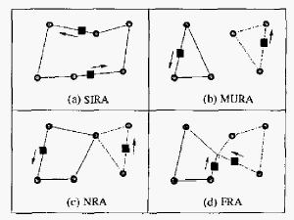
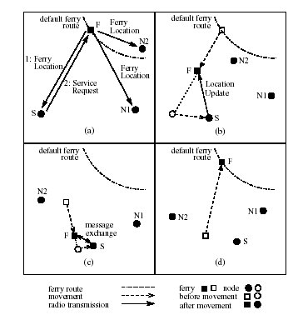
FIMF

The followings are my ideas. My motivation is to discover a mobile ferry without any knowledge of its mobility pattern, such as the default ferry route. In order to simply the problem, we first try to discover a relaying ferry instead of the destination. After that, I will try to discover the mobile destination directly.

Assumption: A sensor network contains stationary sensor nodes (nodes for short) and ferries which take responsibility for delivering messages. This sensor network may be partitioned into some regions for a long period, in each region nodes are deployed densely. So there are two kinds of ferries—inter-region ferries and independent ferries. The former delivers messages within a region, while the latter delivers messages between disconnected regions. As the nodes are stationary, inter-region ferries can determine an optimized route, such as SIRA, denoted as default route, and travel along this route. This route must be well determined to reduce message dropping of nodes. Nodes don’t need to know these default routes in each region. We also assume that independent ferries don’t know these default routes. But independent ferries can move faster than inter-region ones.
Nodes successively produce data during each constant interval, denoted as t. In addition, a node stores its messages to be sent in a particular part of its memory and puts received data in another part. And each time a ferry meets a node, the node will deliver all of its outputs to the ferry due to the large storage capacity of ferries. We assume that nodes and ferries have the same radio range.

Motivation: Previous Message Ferrying Schemes concern with using mobile ferries to deliver messages to stationary destinations in partitioned networks. We concern with using mobile ferries to discover mobile ferries using fusion technologies.

Scenario: In this scenario, when an independent ferry needs to deliver a message to a destination which is in another region, it’s better for it to find one of the inter-region ferries of that region. Because the source can only provide approximate position of the region containing the destination, but can’t provide the position of the destination. Moreover, inter-region ferries get good knowledge of every node in its region. It is more feasible to relay the message to an inter-region ferry than to discover the destination by the independent ferry itself. Because the independent ferry doesn’t know the bound of the region and distributions of nodes, it is not feasible to traverse all the nodes.

Solution: In order to track a mobile inter-region ferry, the independent ferry must get the knowledge of the inter-region ferry’s mobility pattern by analyzing the messages stored at each node. It is obvious that a node will have very less messages to be sent if an inter-region ferry just passed it. Otherwise, there will be many messages to be sent in its memory, if an inter-region ferry has passed for a long period. By the knowledge of nodes’ current storage and the interval time t, the independent ferry can estimate how long the next inter-region ferry will come. Two thresholds, denoted as just-passing and just-coming, can be provided according to the capacity of nodes’ storage and time t. Since we assumed that the default route is well determined to reduce delay and message dropping. So after the independent ferry enters the region which containing the destination, it queries neighboring nodes and collects the knowledge of their current storages. Note that, the only messages exchanged between the independent ferry and nodes contain little data, such as a simple query and an integer number represents the current storage. With these knowledge, the independent ferry starts a fusion process as follows. If the average amount of messages remained to be sent of neighboring nodes is less than just-passing, the independent ferry knows that an inter-region ferry has just passed and decides to follow that inter-region ferry. If the average amount is larger than just-coming, the independent ferry knows an inter-region ferry is coming soon, as the optimally designed ferry route, and decides to wait. Otherwise, the independent ferry knows that an inter-region ferry is far away from here and it is better to move towards it to reduce delay.
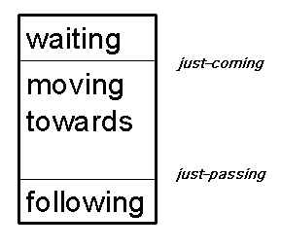
The storage of a node
After making a first phase decision, the independent ferry needs to start another fusion process, either if it decides to move towards or follow an inter-region ferry, to determine the direction of moving.

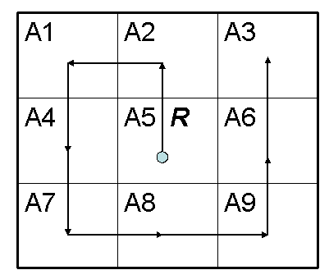
Determine the direction
Assume that the current position, represented as the middle square of the above figure, of the independent ferry is A5. First, the independent ferry moves around A5 with eight steps. And in each step, the independent ferry moves R, which is the diameter of its communication radio, and directions for each step are shown in the above figure. In case of a following decision by last fusion process, the independent ferry needs to discover the direction in which an inter-region ferry just left A5. This direction can be represented by Ai, 1≤i≤9 and i ≠ 5. As the independent ferry moving around, it will collect the average amount of messages to be sent in each square which represents all the one-hop neighbors of the independent ferry. Once the independent ferry gets a smaller value, it gets the decision to move to that square. Because the next area an inter-region ferry entered after it left A5 will have smaller average amount of messages to be sent. The independent ferry can repeat the two phases of fusion processes till it catches an inter-region ferry. In another case of a moving towards decision, the independent ferry starts the same fusion process as described for the previous case, but this time the independent ferry wants to find a square which has the largest average amount of messages to be sent, and moves to that square until it encounters the inter-region ferry or makes a decision of waiting.

Other conditions are also considered, such as the regular nodes can also be mobile or nodes are sparse. In case of mobile nodes, nodes need to know the motions of inter-region ferries. Otherwise, communications must be inefficient, and delay and messages dropping rate must be high. So once an independent ferry meets a node, it can get the knowledge of inter-region ferry easily. It is not interesting. In case of sparse sensor network with mobile nodes, nodes don’t know the motions of ferries (each region contains only one node), maybe the best method is flooding or controlled flooding. This is also not interesting.

